Pumpkin Pie Tofu Pudding
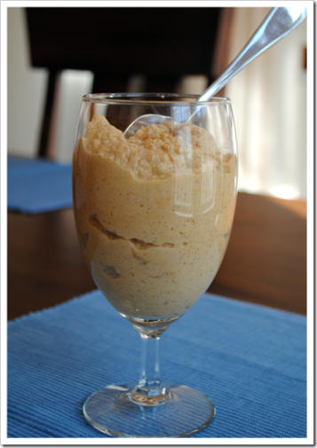
From: Test Kitchen Tuesday
Servings: 4 (about 1/2 cup)
Time Required: 5 minutes prep, not counting passive time to drain and press tofu
Ingredients:
- 1 block of tofu – I used firm, but any will work
- 1/2 cup pumpkin puree
- 1/4 cup skim milk
- 3 tablespoons honey (or other liquid sweetener)
- 1/2 teaspoon ground cinnamon
- 1/4 teaspoon ground ginger
- 1/4 teaspoon ground nutmeg
Note: if you have pumpkin pie spice on hand, you could use 1 teaspoon of that instead of the cinnamon, ginger and nutmeg.
Method:
- Press tofu between a clean dishtowel for about 30 minutes, or as long as you wish (I put it in a colander and then stack a jar of something heavy like pasta sauce on it)
- Break the tofu into 4-5 cubes
- Add all ingredients to a professional blender or food processor, pulsing to combine
- Once combined, blend on low for 1-2 minutes, until mixture is smooth and creamy, scraping down sides of blender/food processor if needed
- Store in an airtight container in the refrigerator for up to five days

Nutrition:

