Easy Veggie Lasagna
From: Test Kitchen Tuesday
Adapted from: Lose Weight for Life – Spinach Eggplant Lasagna
Time Required:
- 15 minutes prep
- 45 minutes to bake lasagna
Skill Level (out of 5):
2Chili’s Taster Rating (out of 5):
Makes: 4 generous servings
Ingredients:
- 1/4 Tablespoon Olive Oil
- 2 medium zucchini, chopped into half moons
- 2 cups fresh spinach
- I jar (plus some, depending on your taste ) organic low-sodium pasta sauce
- 9-12 Lasagna noodles, depending on their width
- 1 cup shredded part-skim mozzarella cheese
- 1/2 cup shredded parmesan cheese

Method:
- Preheat the oven to 375.
- In a medium frying pan, heat olive oil over medium heat. Sautee the zucchini until it is just tender, about 5 to 7 minutes.
- Fully cover the bottom of an 8×8 baking pan with pasta sauce. Layer 4 or 5 of the uncooked lasagna noodles (I overlap them to account for shrinkage). Add the zucchini and cover with sauce. Add another layer of noodles followed by the spinach and another layer of sauce. Add one more layer of noodles, sauce, and cheeses.
- Bake for 45-50 minutes until noodles can easily be pierced with a fork.
- Note: The key with the sauce is to put enough to fully cover each layer. Enough sauce is what makes the noodles cook through and not get crunchy, which is especially important on the top. Also, pre-made pasta sauce is one of the worst offenders of added sodium – and if you’re not careful, you could be way, way, way overdoing it on sodium. Choose a low-sodium variety (less than 50 mg per half cup. Most commercial sauces have about 400-500mg per 1/2 cup – yikes!).

Nutrition:
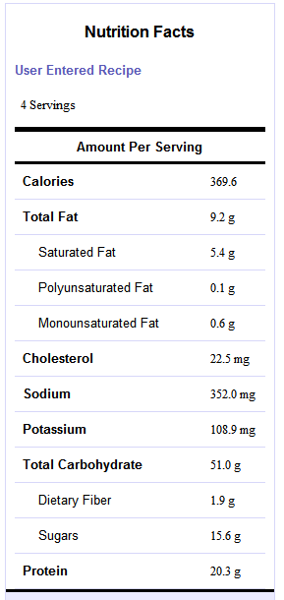 | 